|  |  |
| --- | --- |
| Student Name | Nanthini M |
| Student Roll Number | 710019106032 |
| Team ID | PNT2022TMID42240 |
| Assignment Date | 06 NOVEMBER 2022 |

**IBM ASSIGNMENT – 4**

**Write code and connections in wokwi for ultrasonic sensor. Whenever**

**distance is less than 100 cms send "alert" to ibm cloud and display in**

**device recent events.**

**CODE:**

#include <WiFi.h>

#include <PubSubClient.h>

void callback(char* subscribetopic, byte* payload, unsigned int

payloadLength);

//-------credentials of IBM Accounts------

#define ORG "rqpbgt"//IBM ORGANITION ID

#define DEVICE_TYPE "Nanthinidevice"//Device type mentioned in ibm watson IOT Platform

#define DEVICE_ID "2301"//Device ID mentioned in ibm watson IOT Platform

#define TOKEN "Nandy2001" //Token

String data3;

char server[] = ORG ".messaging.internetofthings.ibmcloud.com";

char publishTopic[] = "iot-2/evt/Data/fmt/json";

char subscribetopic[] = "iot-2/cmd/test/fmt/String";

char authMethod[] = "use-token-auth";

char token[] = TOKEN;

char clientId[] = "d:" ORG ":" DEVICE_TYPE ":" DEVICE_ID;

WiFiClient wifiClient;

PubSubClient client(server, 1883, callback ,wifiClient);

const int trigPin = 5;

const int echoPin = 18;

#define SOUND_SPEED 0.034

long duration;

float distance;

void setup() {

Serial.begin(115200);

pinMode(trigPin, OUTPUT);

pinMode(echoPin, INPUT);

wificonnect();

mqttconnect();

}

void loop()

{

digitalWrite(trigPin, LOW);

delayMicroseconds(2);

digitalWrite(trigPin, HIGH);

delayMicroseconds(10);

digitalWrite(trigPin, LOW);

duration = pulseIn(echoPin, HIGH);

distance = duration * SOUND_SPEED/2;

Serial.print("Distance (cm): ");

Serial.println(distance);

if(distance<100)

{

Serial.println("ALERT!!");

delay(1000);

PublishData(distance);

delay(1000);

if (!client.loop()) {

mqttconnect();

}

}

delay(1000);

}

void PublishData(float dist) {

mqttconnect();

String payload = "{\"Distance\":";

payload += dist;

payload += ",\"ALERT!!\":""\"Distance less than 100cms\"";

payload += "}";

Serial.print("Sending payload: ");

Serial.println(payload);

if (client.publish(publishTopic, (char*) payload.c_str())) {

Serial.println("Publish ok");

} else {

Serial.println("Publish failed");

}

}

void mqttconnect() {

if (!client.connected()) {

Serial.print("Reconnecting client to ");

Serial.println(server);

while (!!!client.connect(clientId, authMethod, token)) {

Serial.print(".");

delay(500);

}

initManagedDevice();

Serial.println();

}

}

void wificonnect()

{

Serial.println();

Serial.print("Connecting to ");

WiFi.begin("Wokwi-GUEST", "", 6);

while (WiFi.status() != WL_CONNECTED) {

delay(500);

Serial.print(".");

}

Serial.println("");

Serial.println("WiFi connected");

Serial.println("IP address: ");

Serial.println(WiFi.localIP());

}

void initManagedDevice() {

if (client.subscribe(subscribetopic)) {

Serial.println((subscribetopic));

Serial.println("subscribe to cmd OK");

} else {

Serial.println("subscribe to cmd FAILED");

}

}

void callback(char* subscribetopic, byte* payload, unsigned int payloadLength)

{

Serial.print("callback invoked for topic: ");

Serial.println(subscribetopic);

for (int i = 0; i < payloadLength; i++) {

//Serial.print((char)payload[i]);

data3 += (char)payload[i];

}

Serial.println("data: "+ data3);

data3="";

}

**SCHEMATIC/CIRCUIT DIAGRAM:**

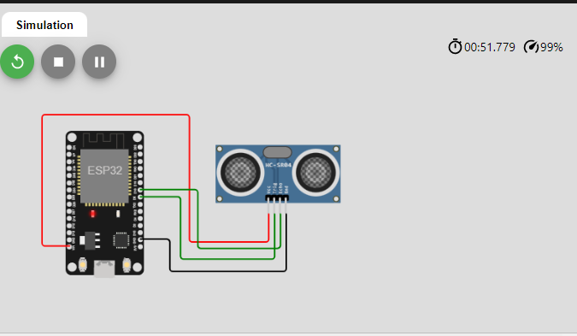

**WOKWI LINK:**

https://wokwi.com/projects/347754834609308243

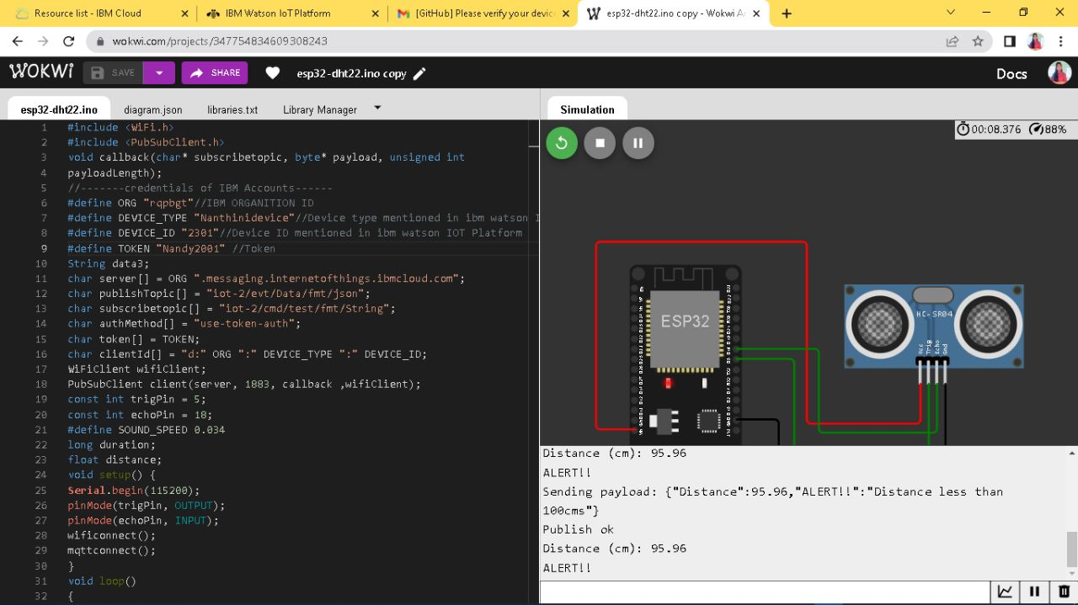**WOKWI OUTPUT:**

**IBM CLOUD OUTPUT :**

